Information and Engineering
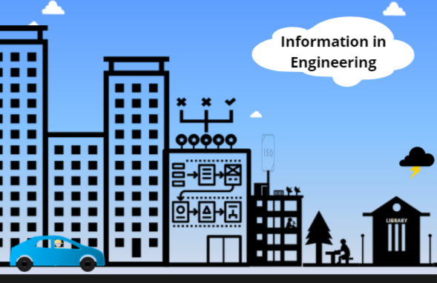
  - Alternative text version.
As a professional engineer you will be required to use information to inform your planning, recommendations and decision making.
The types of information you will use are many and varied, from materials research to standards, weather data, urban developmental plans, population movements, community opinions and attitudes, theoretical research, history and professional specifications from other industries.
What are the consequences of using incorrect, incomplete or insufficient information when making your decisions as a professional engineer?
From lifestyle implications such as poor liveability, traffic jams and unsustainability to huge disasters such as traffic accidents, fires and floods. As an engineer, your decisions will affect the lives and livelihood of others.
These decisions can affect your own livelihood. Engineering failures are likely to have other professional implications, such as
- Loss of clients
- Loss of reputation, and
- Loss of income
When an engineer is found to be at fault for an engineering failure, the most common cause was not the math, or the materials, but ‘insufficient knowledge’ of that engineer.
The common trope is ‘you don’t know what you don’t know’. Therefore, as an engineer you have to be careful to critically assess every angle of a problem, your own knowledge and preconceptions and learn from others experiences in similar situations, before making decisions or recommendations about a solution.
To do this, you need to identify, assess and utilise relevant, up to date, comprehensive and accurate information.
We can help you develop the skills you need to find quality information, quickly and efficiently.

